Data Flow Diagram (DFD)
The Data Flow Diagram illustrates how data moves through the system, from data collection to prediction output.
2.1 Level 0 DFD (Context Diagram)
At the highest level, the system interacts with external entities such as sensors and users.
External Entities
- Motor Sensors
- Users (Engineers, Operators)
Process
- Motor Temperature Prediction System
Data Flows
- Sensor data input
- Predicted temperature output
- Alerts and reports
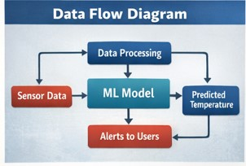

2.2 Level 1 DFD
The system is divided into multiple functional processes:
Process 1: Data Acquisition
- Collects real-time sensor data
- Stores raw data in the database
Inputs
- Current
- Voltage
- Speed
- Ambient temperature
- Torque
Outputs
- Raw sensor dataset

Process 2: Data Preprocessing
- Cleans missing or noisy data
- Normalizes and formats data
- Prepares data for model input
Outputs
- Processed dataset

Process 3: Model Prediction
- Applies machine learning algorithms
- Predicts motor temperature
Outputs
- Predicted temperature values

Process 4: Visualization and Alerts
- Displays predictions on dashboard
- Generates alerts if thresholds are exceeded

2.3 Data Storage
- Historical data repository
- Model training datasets
- Prediction logs

